Mudbox Texturing

1. FIRST FIRST: you need valid geometry

1. mesh>cleanup

select (one at a time!) matching polygons

check lamina faces, manifold geometry, and zero edges

2. select all faces of geometry

3. press ‘apply’

4.then presss move tool to show location of selected face

5.fix

2. In maya: FIRST YOU NEED AN AUTOMATIC UV MAP and a BLINN, then file>send to mudbox>send as new scene

**\*\*\*if this doesn’t work alternative method to move in/out of maya/mudbox is to EXPORT/IMPORT as a FBX file**

3. Another common problem is having the normals reversed (the object will appear ghosty in mudbox) to fix:

1. highlight geometry

2. Normals >Reverse

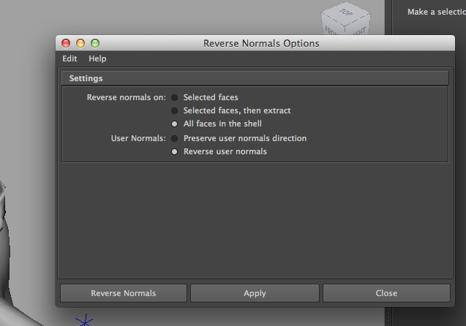

2. Mudbox: top left menu – select paint tab – select new layer button (folder+green arrow)

save as a TARGA 2024x2048

Start with “diffuse layer” – color

3. Bottom menu – select Paint tools tab – paint brush

4. Right click ‘diffuse layer’ >export selected>save in source image directory of project

5. New layer > specular map (removes shininess)

BLACK=not shiny

WHITE= shiny

so use grayscale to your advantage for partial shininess

adjusting strength is a good way to control as well

--little dot to the left of layer allows you to toggle it on and off

6. Nows a good time to save scene, file> save scene> make a separate project because mudbox files get to be huge really fast

7. to export specular >right click layer >export selected

8. Mesh > Add subdivision level. REPEAT (2 levels total)

Lower levels are for general deformations

Work your way up in layers, you create finer and finer detail

example: major muscle definition 🡪 skin texture (on level 3 or 4 depending on your RAM)

9. Switch to SCULPT tab (for top and bottom menus)

10. Check the “use stamp image” in bottom right menu” to use stamps

11. if it’s too intense, use the smooth tool from sculpt tool menu (use flood command with smooth tool to effectively erase everything to start over)

12. you can also create an AO map (for fake shadows—allows for deeper contrast) Maps> Extract Texture Map > New Operation >Ambient Occlusion

default settings are fine

Image Size and Shadow map resolution = 2048x2048

13. Opacity map – to add translucency

14. Maps> Extract Texture Map > New Operation > Normal Map (fancy bump map)

if it looks bumpy- choose anti-alias: 6x

Compatibility:Maya/softimage

coordinate space: tangent

map type: texture

image type (increase bit-depth: tiff 16-bit integer OR open exr 16bit floating

uncheck preview as normal map

export layers, and save scene

15. You want to send your low res model back to maya

Mesh > step level down > repeat until you’re at level 0

File > send mesh to maya > send selected as new scene

BACK IN MAYA